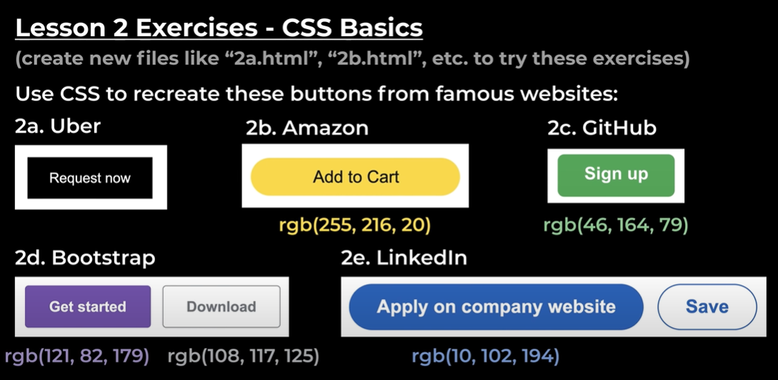

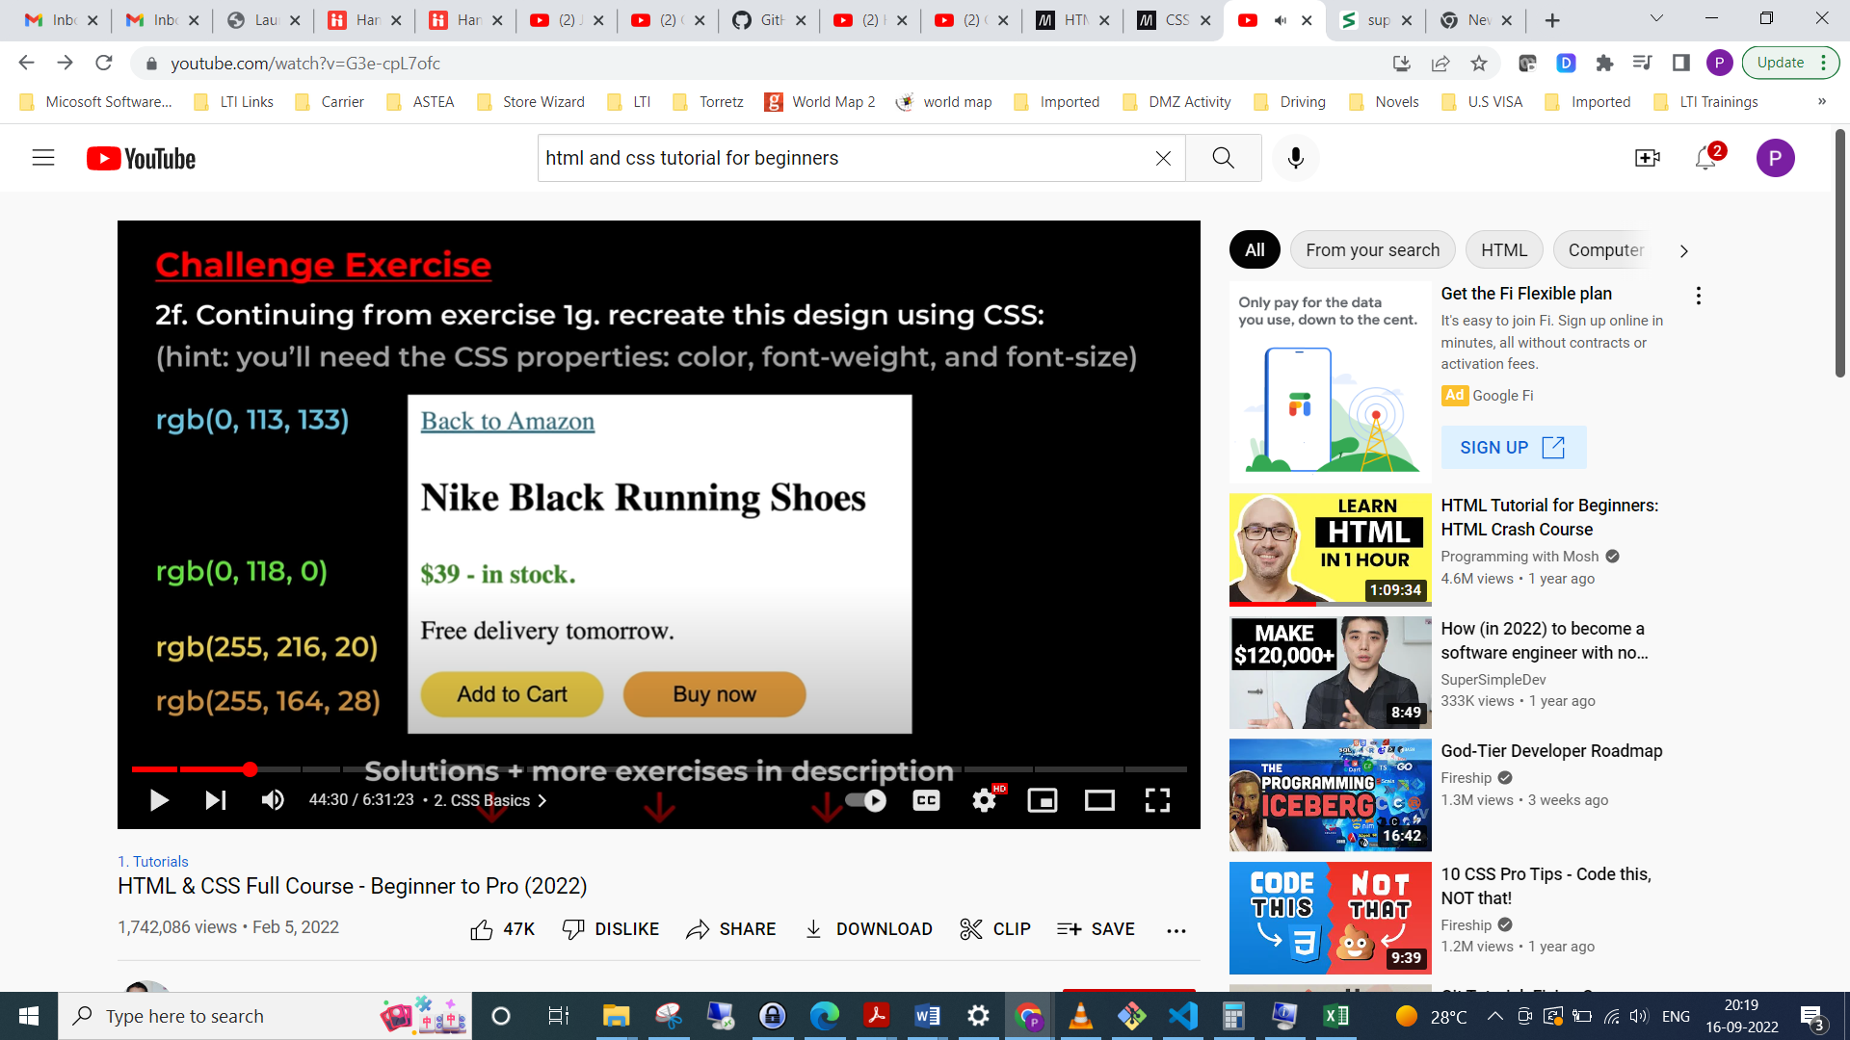

Properties:

Width

Line-height

For adding special characters we use HTML Entity

**Text elements** exist inside of line of text and modify only the specified elements

Ex: <p>How are you today <strong>Jacob</strong>?</p>